EFT points
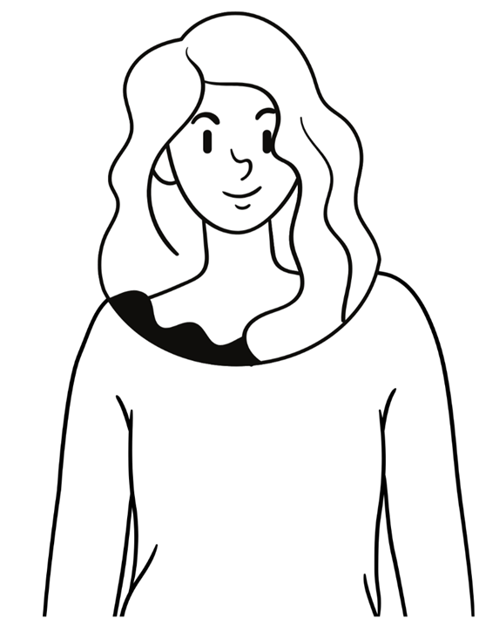
Top of the head Eyebrow
point Side of the
Eye Under the eye

Under the
Nose Chin

Collarbone Under arm

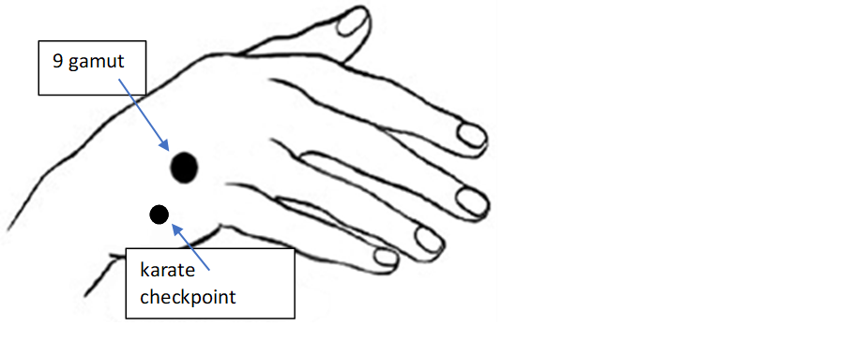

Start with the “Karate Checkpoint”
Even though (probleme/theme/thought)………….I deepley and completly love and accept myself 3 x
Then start with the tappingpoints on your body (see tapping points above). Tap on all the points minimal 7x.

